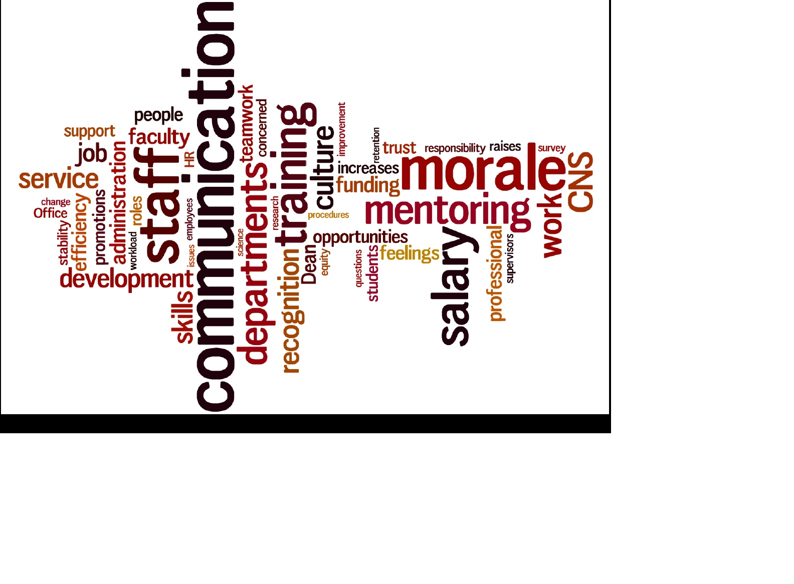

Report from the

College of Natural Sciences Staff Task Force

Regarding

Staff Issues and

Recommendations for Improvement

January 2014

Table of Contents

Acknowledgements1

Introduction to the Report1

Issue Statements2

Communication2

Training and Education3

Morale and Culture4

Recommendations for change5

Conclusion 8

Appendices8

Appendix 1: Staff Survey Results Summary 8

Appendix 2: Staff Survey Results 12

** The cover word cloud was created with the staff comments from the CNS Staff Task Force Survey. The larger the font size is in the word cloud, the higher the frequency of that word in the survey comments.

Acknowledgements

We would like to thank Dr. Cathy Stacy for her guidance and encouragement throughout this process. We would also like to acknowledge Megan Reilly for her administrative support of the Task Force. Finally, we are grateful to Dean Hicke for providing the staff this opportunity to play a more active role in the College of Natural Sciences and allowing us to share our recommendations with her.

Introduction:

The staff of the College of Natural Sciences plays an integral role in the college’s commitment to preparing tomorrow’s leaders and to science and discovery. From ensuring our students enroll in the correct courses, to providing crucial data to faculty applying for grants, staff members contribute every day to the success of the College. We are driven by the pride that comes from working in one of the best science colleges in the country. We also value being recognized for our contributions.

In September 2013, Dr. Cathy Stacy solicited applications from CNS staff to serve on a task force. The group was charged with the task of identifying ways in which CNS could better integrate and support its staff, to identify issues of staff concerns and to make recommendations for improvement when possible. The recommendations were to be budget neutral, have broad impact, and be implementable. The following ten staff members were selected to serve:

Martha Berry, Program Coordinator, School of Human Ecology  
Julie Bowers, Administrative Manager, Undergraduate Education  
Sandra Catlett, Senior Graduate Coordinator, Mathematics  
Cecil Harkey, DNA Facility Lab Manager, ICMB  
Norma Hernández, Senior Academic Advisor, Biology Advising Center  
Ann Marie Holliday, Accounts Payable Manager, Chemistry  
Daniel Machold, Senior Software Engineer, Computer Science  
Sylvia Moore, Administrative Associate, Integrative Biology  
Katherine Reynolds, Project Manager, Research & Facilities  
Liz Wyckoff, Research Scientist, Molecular Biosciences

The Task Force met bi-weekly throughout the fall semester and into January 2014. Discussions during these meetings led to the identification of three target areas for improvement:

1. Communication
2. Training and Education
3. Morale and Culture

The Task Force split into subcommittees to delve deeper into each area. In this report we provide recommendations for ways in which the College can better serve, support and enhance the staff in these three areas.

As a supplement to our own discussions and informally soliciting feedback from colleagues, we surveyed the entire staff of the College. The survey was sent to 1,286 people and the Task Force received 479 responses. The results of this survey confirmed the Task Force’s issue areas and recommendations. Survey results are provided in the appendix to this report.

Issue statements:

The first duty of the CNS Staff Task Force was to identify areas where an impact can be made. The issue areas are divided into three main categories as identified throughout the course of the fall semester by the members of the Task Force, colleague feedback and the staff survey. The Task Force worked hard to get to the heart of the issues. This is not an exhaustive list of issues faced by CNS staff, but includes several concerns that follow the designated parameters (discussed above).

Communication

Communication problems within the college have resulted in the inefficient use of CNS staff resources, including duplication of efforts, delays in the completion of essential tasks and unnecessary overtime due to uneven workflow. Additionally, ineffective communication up the administrative ladder has led to the inability to efficiently identify, prioritize and address problems as they arise. This also leaves staff members feeling that they are not included in, or adequately informed about, policy decisions that directly affect their work. These issues have a negative effect on staff morale and lead to higher turnover rates.

Specific concerns:

* + Staff members are not consistently notified of changes in policy, staff, and departmental reorganizations within CNS. It is unclear to whom departmental staff should contact at the College level for help with specific problems.
  + Staff members have no voice in policy changes, even when those policy changes directly affect their duties.
  + Staff members are not included in search committees for major department hires though positions may include administrative responsibilities that affect staff.
  + Response times from the CNS Business Office are frequently slow, at times taking up to six weeks or more. Further, when a question or problem arises, there is often poor communication to resolve the issue in a timely manner. There is only a single person with the ability to approve certain documents, which contributes to delayed processing times.
  + Deadlines for information requested from different branches throughout CNS frequently overlap. For example, due dates for large data-driven projects from academics and business affairs may fall in the same month, and occasionally, the same week.
  + There is not a consistent, maintained policy for staff evaluations. Many employees do not receive constructive feedback on their work performance and, in turn, lack a formal opportunity to discuss changes within their department that may help them enhance their productivity.

Training and Education:

One of the strengths of having a strong staff is that over time they become a repository of institutional knowledge. As staff members leave for other opportunities or retire, that institution knowledge is often lost. Additionally, as positions change and evolve there is an ongoing need for continued training and education. Therefore it is important to provide staff proper training when they begin positions, ongoing education, and capture their job and institutional knowledge before they move on from CNS.

Specific concerns:

* + In many areas, job specific training is either not available or inadequate for new employees as well as employees entering a new position or adopting new job functions. This includes College-specific policies and procedures. Lack of or inadequate training has had a major impact on staff due to restructuring of existing positions or reorganizations. An example would be CNS travel policies that are confusing with possible ramifications for personal financial loss to the traveler.
  + Institutional knowledge is not documented. This is partly due to the fact that the workload of positions does not allow time for this practice. Lack of documentation for existing positions is only addressed when an incumbent leaves a position. Without this knowledge it takes longer for employees to get up to speed and more difficult to find answers to typical tasks.
  + Professional development, continuing education, and chances to attend national conferences are limited. All employees should be given equal opportunity to all training, educational opportunities, and conferences.
  + Supervisors are generally not involved in the training process. This responsibility often falls to the existing staff. There is a lack of supervisory support for employees to attain more training for the enhancement of job duties and performance.

Morale and Culture

Morale can be defined as unit cohesion or a certain esprit de corps, a core philosophy within the foundation of the Dean’s Office and at the department level. CNS is losing and will continue to lose staff members along with the experience, institutional knowledge, time and money spent training them. Additionally, the isolation of certain individuals and units due to physical location or lack of CNS involvement can cause frustration and degraded cohesion of the unit.

Specific concerns:

* + Low staff morale and lack of community in CNS leads to staff turnover. With limitations in pay, it is even more critical to focus on improving morale and creating a feeling of camaraderie within the college to retain and attract quality staff personnel.
  + There is a lack of understanding and appreciation of staff roles in CNS. If the faculty were more knowledgeable about the staff roles and processes, it would allow departments to function more efficiently. This acknowledgement would also lead to an increased appreciation of the staff.

Recommendations for change:

As the Task Force met to discuss our issues and recommended reform options, we found that there was significant overlap between the subcommittees. For example, a staff liaison could help coordinate communication, facilitate training as well as establish a collegial environment where all staff feel valued and appreciated for their contributions. For that reason, the following 14 reforms are not organized by the three main issue areas. We have tried to prioritize the recommendations by importance and feasibility. Again, this is not an exhaustive list, but has been pared down to include the most important recommendations given the Task Force mission.

Suggested reforms:

* The staff would like CNS to appoint a single point-person within the Dean’s Office to act as a liaison for staff. We are the only large group within the college without a specific contact, since the undergraduates, graduate students, post-docs and faculty already have one. This position would be responsible for communicating information from the Dean’s Office to all staff, including changes in policy, changes in contact information (such as new building managers), upcoming events, one-time training opportunities, etc. This could be accomplished inexpensively through the establishment of a list-serve for staff members. This position would also act as a contact person within the Dean’s Office. In some cases the liaison may also need to assist in follow-up, to ensure that issues brought to the Dean’s Office are appropriately addressed.
* Create a permanent CNS Staff Leadership Group for ongoing input, leadership, training, resources, etc. as identified in the CNS Strategic Plan action item #8. The CNS Staff Task Force could help identify and structure this group that should be comprised of at least one person from each unit and the Staff Liaison. This leadership group should maintain a relationship with the Staff Ombudsperson, EAP and other staff support organizations to make sure they address issues of concern to staff. This group could also provide an opportunity for inclusion of staff in college and department level policy decisions.
* Provide a dedicated space for all CNS staff to use for coordinating community building activities, meetings, collaboration on large projects, mentoring, lunches, store materials for staff use, etc. The CNS Staff Leadership Group will help maintain this administrative core facility.
* Develop a webpage on the CNS website devoted solely to staff-related topics and resources. This website would supplement the list-serve as a one-stop place to display current contact information, policy changes and other announcements. It should also include an online resource to for informational contacts. This can be similar to the “Experts Guide,”[1] but an internal list for CNS staff. It would also be a repository for resources such as links to administrative forms, CNS and University policies and procedures, CNS and departmental calendars, and core facilities. The website should include a forum for discussion of issues, such as staff concerns, best practices, and lab procedures. The forum should be monitored by the staff liaison, who could respond to recurring issues on an FAQ page. The webpage should also include a drop-box where individuals can leave concerns, complaints, or other comments in a manner that is genuinely anonymous. Staff feedback and issues of concern should be monitored and addressed by the Staff Liaison. The webpage would be inexpensive to implement, and could be created by current CNS IT and Communications groups.
* A College-wide peer-lead lecture series or informal brown bags should be established to provide an opportunity for experienced senior staff to train others in an efficient way, while providing contacts for specific questions. Additionally, this would be a way to honor a staff member and provide recognition for their expertise, while acknowledging the extra work that many of our staff who are already contributing.
* Improve communication between units within the College of Natural Sciences so that due dates for large, labor-intensive projects are strategically timed and do not fall concurrently.
* Develop a formal policy for meaningful staff evaluations and enforce that policy across the college. Consider instituting a 360-evaluation process.
* While considering the budget constraints, more effort should be put into making the scarce opportunities to attend national conferences open to all. An application for a travel award should be available to make these opportunities more competitive. Additionally, the award winner should be responsible for the dissemination of the knowledge gained. This would be another opportunity for a peer-lead lecture. This would provide more of the College, and its staff, the opportunity to benefit from the funding that is already set-aside for this purpose.
* The establishment of a job handbook that would preserve the institutional knowledge of a position, allowing new employees, or employees with similar job functions, to learn from senior and experienced people. It is our suggestion that a portion of every work week is dedicated to documenting the details of one’s position.
* Encourage supervisors to adopt policies that allot a specific amount of time (5%) of each work week dedicated to training, planning, professional development, and documentation of job duties.
* Provide opportunities for all levels of staff to give input on changes in policy, major department hires, departmental reorganizations, and changes in building infrastructure. Staff should have a representative on committees overseeing these types of changes. Feedback from staff could also be solicited through town hall meetings or a forum on the staff website.
* Provide opportunities for staff (administrative and lab) and faculty to learn about each other’s work. This will facilitate a better understanding of various roles and processes that go into making the work units successful. This can provide leadership opportunities for staff members.
* Facilitate an environment in the College and in departments that values the contribution of all staff, including lab staff and other non-administrative staff. Preserve existing and create new traditions to help develop bonds within CNS and the working units. Some suggestions are:
* Awards and recognition e.g. acknowledging years of service, taking on additional duties, staff that go above and beyond. This can range from the large-scale yearly CNS awards to smaller acknowledgements of job well done on a particular task.
* Create an informal, fun, and interactive newsletter across the college to facilitate the sharing of information across work units. This could include personal announcements (weddings, births, etc.), information about promotions, updates on units, events, letters to the editor, etc. This could include staff spotlight about diverse jobs and accomplishments.
* Incentives to show staff are valued even if raises are not possible e.g. temporary parking spot, gym membership, floating holidays, etc.
* Create opportunities for faculty, staff and students to build community and interact socially outside of the classroom or work processes. Some departments already have community building events that we can do at the college level, such as:
  + Holiday parties, picnics, ice cream social, retreats
  + Talent show or Art show
  + Friendly competitions e.g. Staff/faculty/student sports leagues, trivia competitions or cook-offs
  + Group volunteering for events inside and outside of the university

Conclusion:

Like our faculty and students, the CNS staff members are a diverse group of people. We work in many different roles and have many different opinions on the issues that we face and the best ways to solve those problems. We hope that this report and proposed recommendations are thought of as the start of a conversation rather than an exhaustive agenda. As our environment is ever-changing, CNS will face new and different issues in the future. The CNS Staff Task Force hopes that by implementing these recommendations, our staff will be better prepared to face new challenges and opportunities for growth.

Appendix 1: Staff Survey Summary

The Staff Task Force hoped to maintain our mission of representing the diversity of CNS staff while isolating specific concerns that would generalize across all domains. In order to do so, we gained information through individual contact with coworkers from our own departments, as well as, an anonymous online survey. The data polled from this survey has been attached in its entirety in Appendix 2 of this report. The Task Force used these data to help guide our conversations regarding key concerns and possible solutions.

The survey consisted of five Likert items that focused on broad topics and two open-ended questions with comment sections. Likert items were written on a 7-point scale, lower scores indicate lower satisfaction. Below represents a brief summary of the results:

1. How long have you worked at UT?

34% of respondents have worked at the University for less than 5 years.

2. How long have you worked at the College of Natural Sciences?

33% of respondents have been employed by CNS less than 3 years.

32% have been in CNS longer than 10 years.

3. Which category best defines you?

The survey was sent to a variety of staff members.

4. How satisfied are you with your employment in the College of Natural Sciences?

33% of survey participants reported neutral feelings regarding their satisfaction with CNS. However, 55% of responses were very to extremely satisfied.

5. Rate your satisfaction with the following areas:

Responses show that satisfaction regarding personal ‘salary’ is fairly neutral and evenly distributed (M=3.88, SD=1.77). Still, ‘the frequency and amount of salary increases’ (M=2.75, SD=1.75) depicts dissatisfied staff. A large majority of the written responses to the survey highlighted the need for commensurate salary increases amongst staff positions. Survey responses show that most participants are dissatisfied with ‘the connection between pay and performance’ (M=3.21, SD=1.80).

The survey does suggest that acknowledgment does present itself in other forms. Staff satisfaction slightly increased with regard to ‘recognition received for job performance’ (M=4.54, SD=1.95). Though, these results are not meaningfully positive.

Staff responses indicate that satisfaction was low regarding the ‘ability to influence day-to-day CNS successes’ (M=3.94, SD=1.63), ‘ability to influence decisions that affect you’ (M=4.02, SD=1.79), ‘job security’ (M=4.19, SD=1.75), and ‘opportunity for advancement’ (M=3.69, SD=1.74). Negative associations with each of these categories are echoed throughout the comment sections of the survey.

Satisfaction with ‘communication with your supervisor’ (M=5.36, SD=1.70), ‘supervisor’s management capabilities’ (M=4.98, SD=1.92), and ‘overall relationship with your supervisor’ (M=5.50, SD 1.67) were marginally positive. Individual comments suggest that Faculty acting as Administrative Managers have been unsuccessful at cultivating positive relationships with their staff.

The ‘opportunity to use new technology’ (M=4.94, SD=1.51) and ‘access to college-sponsored training and seminars’ (M=4.47, SD=1.70) also generate neutral to slightly positive responses.

Overall, participating staff are satisfied with their ‘physical working environment’ (M=5.24, SD=1.48), the ‘flexibility of their work hours’ (M=5.52, SD=1.44) and their ‘workload’ (M=4.38, SD=1.63).

Satisfaction with ‘your relationship with your peers’ (M=5.95, SD=1.16) elicited the most positive response from the survey. ‘Opportunities for team-building’ (M=4.74, SD=1.71) and ‘overall satisfaction’ (M=4.92, SD=1.57) were also marginally positive.

Items 6 and 7 requested open-ended feedback for suggestions for improvement and an opportunity to express individual concerns. Many written responses spoke to the management of the budget and the uncertainty of potential lay-offs. Poor communication was a major theme across most responses. Individuals suggest that not only would better communication increase efficiency and workflow, it would increase morale. Unproductive communication with other offices, such as the Dean’s Business Office, was considered extremely negative throughout the written responses to the survey. General uncertainty is plaguing most employees. Information is disseminated through rumors, or not at all. The lack of College-wide conversation and updates is isolating to staff and is having a negative impact on their perception of the College’s progress to achieve many goals, including those outlined in the strategic plan. The following are a few excerpts from survey:

Communication

*“Communication and timely assistance from the Dean's Office, particularly from those who enforce policy--HR, accounting, etc.. Too often requests for guidance go unanswered, and then documents created with uncertainty get routed through HRMS/DEFINE only to get rejected without an explanation of why. Greater consistency and transparency of policy and procedure, similar to what COLA has online, would be a timesaver and a frustration reliever. It's telling that my "go-to" people for questions are entirely outside of CNS Dean's Office.”*

*“Over the past 20+ years I have worked for several UT colleges, and the CNS Dean's Office by far is the worse in terms of working together with departmental staff to work through a vast array of administrative needs. I don't find the CNS web page to be a very useful tool to find answers to commonly encountered administrative issues. And there is a general sense of distrust between my department and the CNS Dean's Office. Whereas in the past I have worked with Dean's offices that fostered a "team" environment. From my very first visit to the CNS Dean's Office, just the way it's setup, I knew the staff was not approachable.”*

Staff Recruitment

*“I have some concerns that CNS lags behind peer colleges on campus in terms of how it employs staff. There still seems to be a perception in many corners that staff's role is an afterthought relative to the faculty and at worst administrative or para-professional. Bad habits like relying solely on the existing HR system for hiring staff rather than proactively recruiting top talent is emblematic of this problem and leads to poor hiring. The college's antiquated views on staffing fail to recognize how much it has to gain from fully professionalizing its staff and chases off the best individuals, who do want a professional work environment. A good analogy to this would be a place like Apple. What if only the technologists were considered mission critical and they low-balled their hires in business affairs or marketing or consumer research or legal? Our faculty may be our heart, but you can't function without arms and legs. A more thoughtful, systematic approach to phasing out paraprofessionals and bringing in more professionals would be ideal.”*

Supervisors

*“In my experience, the College has done a poor job of holding managers accountable for their units. This has created an enormous amount of wasted effort and talent in my division, which has engendered disharmony among the "boots on the ground," causing some of the more experienced and productive employees to leave. This impacts the morale of those remaining, and in the long run hurts the mission of teaching and research that the University and the people of Texas have come to expect.”*

*“My supervisor has a great deal of care and gives a tremendous amount of his time to students which is admirable, but I, and others, wish he had availability and expressed similar concern or interest for his staff. There are many times when I don't feel trusted to do my job and I don't feel comfortable sharing my opinion or expertise because even in one-on-one conversations, I feel like I'm talking to myself. I feel like I'm either being micromanaged or placated with very surface level engagement and that people don't know (which translates to they don't care) what I do. I feel isolated. I know the importance of my role and the potential impact, but I don't believe others do, including the leadership at-large, which makes it very difficult to feel valued. I don't know if it's possible to change a work environment to that level or train a respected faculty member to be a better administrative manger and to be able to connect on a basic human level, but if there is a way, that would be a huge step in improving the work environment and morale making CNS a better place to work. Relationships and trust matter and while I have good relationships with most others on or about my same level, we're all experiencing similar challenges and disappointments.”*

Lack of Community

*“I would like more opportunities for the people who work at the Marine Science Institute in Port Aransas. Because we are not on main campus, I feel as though it is rare that Austin people come down here and give us the same opportunities at those in Austin. Another option might be to have HR classes and stuff that are offered be available over video-link or webinar.”*

*“Not sure how, but if there was something that could be done that would make us (Division of SSC) feel less like the odd step child and more like an important part of CNS.”*

Culture

*“We seem to have a culture of "silos". Changing that will not be easy, but having opportunities for counterparts from each school/department to meet on a regular basis to discuss concerns and changes in policy/procedures would be helpful. We need to see the faces of those people we interact with by email and phone. We need to build relationships!! Training from HR and Business Affairs on what processes are and how they want documentation/information sent to them so that things don't get slowed down because things have to be sent back for correction, would be appreciated. We have great people working in CNS. And they want to do a good job. Sometimes we need more education from in-house to help us all work together better and more efficiently.”*

Appendix 2: Staff Survey Results

1. How long have you worked at UT?

|  |  |  |  |  |  |  |
| --- | --- | --- | --- | --- | --- | --- |
| # | Answer | |  |  | | --- | --- | |  |  | | Response | % |
| 1 | 3 months - 1 year | |  |  | | --- | --- | |  |  | | 32 | 7% |
| 2 | 1- 5 years | |  |  | | --- | --- | |  |  | | 128 | 27% |
| 3 | 6 - 10 years | |  |  | | --- | --- | |  |  | | 114 | 24% |
| 4 | 11 - 15 years | |  |  | | --- | --- | |  |  | | 91 | 19% |
| 5 | 16 - 20 years | |  |  | | --- | --- | |  |  | | 45 | 9% |
| 6 | 21 - 26 years | |  |  | | --- | --- | |  |  | | 29 | 6% |
| 7 | 26 - 30 years | |  |  | | --- | --- | |  |  | | 15 | 3% |
| 8 | 30+ years | |  |  | | --- | --- | |  |  | | 20 | 4% |
|  | Total |  | 474 | 100% |

|  |  |
| --- | --- |
| Statistic | Value |
| Min Value | 1 |
| Max Value | 8 |
| Mean | 3.50 |
| Variance | 2.98 |
| Standard Deviation | 1.73 |
| Total Responses | 474 |

2. How long have you worked in the College of Natural Sciences?

|  |  |  |  |  |  |  |
| --- | --- | --- | --- | --- | --- | --- |
| # | Answer | |  |  | | --- | --- | |  |  | | Response | % |
| 1 | 3 months - 1 year | |  |  | | --- | --- | |  |  | | 47 | 10% |
| 2 | 1 - 3 years | |  |  | | --- | --- | |  |  | | 108 | 23% |
| 3 | 4 - 6 years | |  |  | | --- | --- | |  |  | | 98 | 21% |
| 4 | 7 - 10 years | |  |  | | --- | --- | |  |  | | 64 | 14% |
| 5 | 10 - 15 years | |  |  | | --- | --- | |  |  | | 87 | 18% |
| 6 | 15 - 20 years | |  |  | | --- | --- | |  |  | | 35 | 7% |
| 7 | 20+ years | |  |  | | --- | --- | |  |  | | 35 | 7% |
|  | Total |  | 474 | 100% |

|  |  |
| --- | --- |
| Statistic | Value |
| Min Value | 1 |
| Max Value | 7 |
| Mean | 3.59 |
| Variance | 2.99 |
| Standard Deviation | 1.73 |
| Total Responses | 474 |

3. Which category best identifies you?

|  |  |  |  |  |  |  |
| --- | --- | --- | --- | --- | --- | --- |
| # | Answer | |  |  | | --- | --- | |  |  | | Response | % |
| 2 | IT | |  |  | | --- | --- | |  |  | | 28 | 6% |
| 3 | Research Laboratory Staff | |  |  | | --- | --- | |  |  | | 125 | 26% |
| 4 | Communications | |  |  | | --- | --- | |  |  | | 12 | 3% |
| 5 | Student Support (i.e. Graduate, Undergraduate, Academic Advisor, Non-academic Counselor, Career Services, Instructional Lab Support) | |  |  | | --- | --- | |  |  | | 75 | 16% |
| 6 | Other Administration | |  |  | | --- | --- | |  |  | | 38 | 8% |
| 9 | Other | |  |  | | --- | --- | |  |  | | 60 | 13% |
| 10 | Development | |  |  | | --- | --- | |  |  | | 13 | 3% |
| 11 | Facilities (i.e. Building Manager, Mechanical Support, Core Facilities, Shops, Service Centers) | |  |  | | --- | --- | |  |  | | 34 | 7% |
| 12 | Department Administration (i.e. Accounting, HR, Procurement, Other) | |  |  | | --- | --- | |  |  | | 89 | 19% |
|  | Total |  | 474 | 100% |

|  |  |
| --- | --- |
| Statistic | Value |
| Min Value | 2 |
| Max Value | 12 |
| Mean | 6.74 |
| Variance | 13.19 |
| Standard Deviation | 3.63 |
| Total Responses | 474 |

4. How satisfied are you with your employment in the College of Natural Sciences?

|  |  |  |  |  |  |  |
| --- | --- | --- | --- | --- | --- | --- |
| # | Answer | |  |  | | --- | --- | |  |  | | Response | % |
| 0 | Extremely satisfied | |  |  | | --- | --- | |  |  | | 46 | 10% |
| 1 | Very satisfied | |  |  | | --- | --- | |  |  | | 213 | 45% |
| 2 | Neither satisfied nor dissatisfied | |  |  | | --- | --- | |  |  | | 156 | 33% |
| 3 | Very dissatisfied | |  |  | | --- | --- | |  |  | | 47 | 10% |
| 4 | Extremely dissatisfied | |  |  | | --- | --- | |  |  | | 12 | 3% |
|  | Total |  | 474 | 100% |

|  |  |
| --- | --- |
| Statistic | Value |
| Min Value | 0 |
| Max Value | 4 |
| Mean | 1.51 |
| Variance | 0.80 |
| Standard Deviation | 0.89 |
| Total Responses | 474 |

5. Please rate your satisfaction with the following.

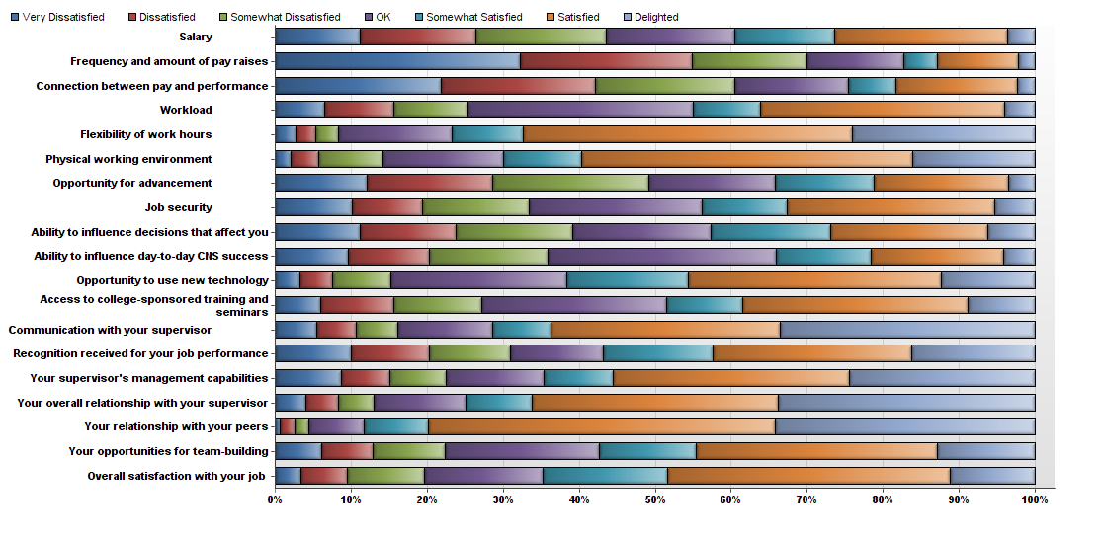

|  |  |  |  |  |  |  |  |  |  |  |
| --- | --- | --- | --- | --- | --- | --- | --- | --- | --- | --- |
| # | Question | Very Dissatisfied | Dissatisfied | Somewhat Dissatisfied | OK | Somewhat Satisfied | Satisfied | Delighted | Total Responses | Mean |
| 1 | Salary | 53 | 72 | 81 | 80 | 62 | 108 | 17 | 473 | 3.88 |
| 2 | Frequency and amount of pay raises | 146 | 102 | 68 | 58 | 20 | 48 | 10 | 452 | 2.75 |
| 3 | Connection between pay and performance | 101 | 94 | 85 | 69 | 29 | 74 | 11 | 463 | 3.21 |
| 4 | Workload | 31 | 43 | 46 | 140 | 42 | 152 | 19 | 473 | 4.38 |
| 5 | Flexibility of work hours | 13 | 12 | 14 | 70 | 44 | 203 | 113 | 469 | 5.52 |
| 6 | Physical working environment | 10 | 17 | 40 | 75 | 48 | 206 | 76 | 472 | 5.24 |
| 7 | Opportunity for advancement | 54 | 74 | 92 | 75 | 58 | 79 | 16 | 448 | 3.69 |
| 8 | Job security | 47 | 43 | 66 | 106 | 52 | 127 | 25 | 466 | 4.19 |
| 9 | Ability to influence decisions that affect you | 52 | 59 | 72 | 85 | 73 | 97 | 29 | 467 | 4.02 |
| 10 | Ability to influence day-to-day CNS success | 42 | 46 | 68 | 131 | 54 | 76 | 18 | 435 | 3.94 |
| 11 | Opportunity to use new technology | 15 | 19 | 35 | 105 | 73 | 151 | 56 | 454 | 4.94 |
| 12 | Access to college-sponsored training and seminars | 26 | 41 | 50 | 105 | 43 | 128 | 38 | 431 | 4.47 |
| 13 | Communication with your supervisor | 26 | 24 | 26 | 59 | 36 | 142 | 158 | 471 | 5.36 |
| 14 | Recognition received for your job performance | 47 | 49 | 50 | 58 | 68 | 123 | 77 | 472 | 4.54 |
| 15 | Your supervisor's management capabilities | 41 | 30 | 35 | 60 | 43 | 146 | 115 | 470 | 4.98 |
| 16 | Your overall relationship with your supervisor | 19 | 20 | 22 | 57 | 41 | 152 | 159 | 470 | 5.50 |
| 17 | Your relationship with your peers | 3 | 9 | 9 | 34 | 40 | 214 | 161 | 470 | 5.95 |
| 18 | Your opportunities for team-building | 28 | 31 | 43 | 93 | 58 | 145 | 59 | 457 | 4.74 |
| 19 | Overall satisfaction with your job | 16 | 29 | 48 | 74 | 78 | 176 | 53 | 474 | 4.92 |

|  |  |  |  |  |  |  |  |  |  |  |  |  |  |  |  |  |  |  |  |
| --- | --- | --- | --- | --- | --- | --- | --- | --- | --- | --- | --- | --- | --- | --- | --- | --- | --- | --- | --- |
| Statistic | Salary | Frequency and amount of pay raises | Connection between pay and performance | Workload | Flexibility of work hours | Physical working environment | Opportunity for advancement | Job security | Ability to influence decisions that affect you | Ability to influence day-to-day CNS success | Opportunity to use new technology | Access to college-sponsored training and seminars | Communication with your supervisor | Recognition received for your job performance | Your supervisor's management capabilities | Your overall relationship with your supervisor | Your relationship with your peers | Your opportunities for team-building | Overall satisfaction with your job |
| Min Value | 1 | 1 | 1 | 1 | 1 | 1 | 1 | 1 | 1 | 1 | 1 | 1 | 1 | 1 | 1 | 1 | 1 | 1 | 1 |
| Max Value | 7 | 7 | 7 | 7 | 7 | 7 | 7 | 7 | 7 | 7 | 7 | 7 | 7 | 7 | 7 | 7 | 7 | 7 | 7 |
| Mean | 3.88 | 2.75 | 3.21 | 4.38 | 5.52 | 5.24 | 3.69 | 4.19 | 4.02 | 3.94 | 4.94 | 4.47 | 5.36 | 4.54 | 4.98 | 5.50 | 5.95 | 4.74 | 4.92 |
| Variance | 3.15 | 3.08 | 3.26 | 2.65 | 2.07 | 2.19 | 3.02 | 3.07 | 3.21 | 2.65 | 2.27 | 2.91 | 3.21 | 3.79 | 3.69 | 2.78 | 1.36 | 2.94 | 2.47 |
| Standard Deviation | 1.77 | 1.75 | 1.80 | 1.63 | 1.44 | 1.48 | 1.74 | 1.75 | 1.79 | 1.63 | 1.51 | 1.70 | 1.79 | 1.95 | 1.92 | 1.67 | 1.16 | 1.71 | 1.57 |
| Total Responses | 473 | 452 | 463 | 473 | 469 | 472 | 448 | 466 | 467 | 435 | 454 | 431 | 471 | 472 | 470 | 470 | 470 | 457 | 474 |

**Staff Comments:**

Questions number six and seven of the survey requested feedback from the staff to the following two questions.

6. If you could change/improve something in the College of Natural Sciences that would allow you to perform your job better what would it be?

7. As a staff member, are there any other comments/concerns you have regarding the College of Natural Sciences?

In order to preserve anonymity of the staff, the responses have been redacted from this report for dissemination purposes. All comments were submitted to Dean Hicke in their raw form.

1. <http://www.utexas.edu/opa/experts/browse/subject.php?e=0,2>